**PYTHON**

**ASSESSEMENT**

S.R.TAANUSRI

20.12.2023

1. Explain Python Module with examples

a.Import module in Python

b.Renaming the Python module

* a file containing Python definitions and statements.
* way to organize code.
* imported using the import keyword
* allowing access to functions, classes, and variables defined in the module.

a. Import module in Python

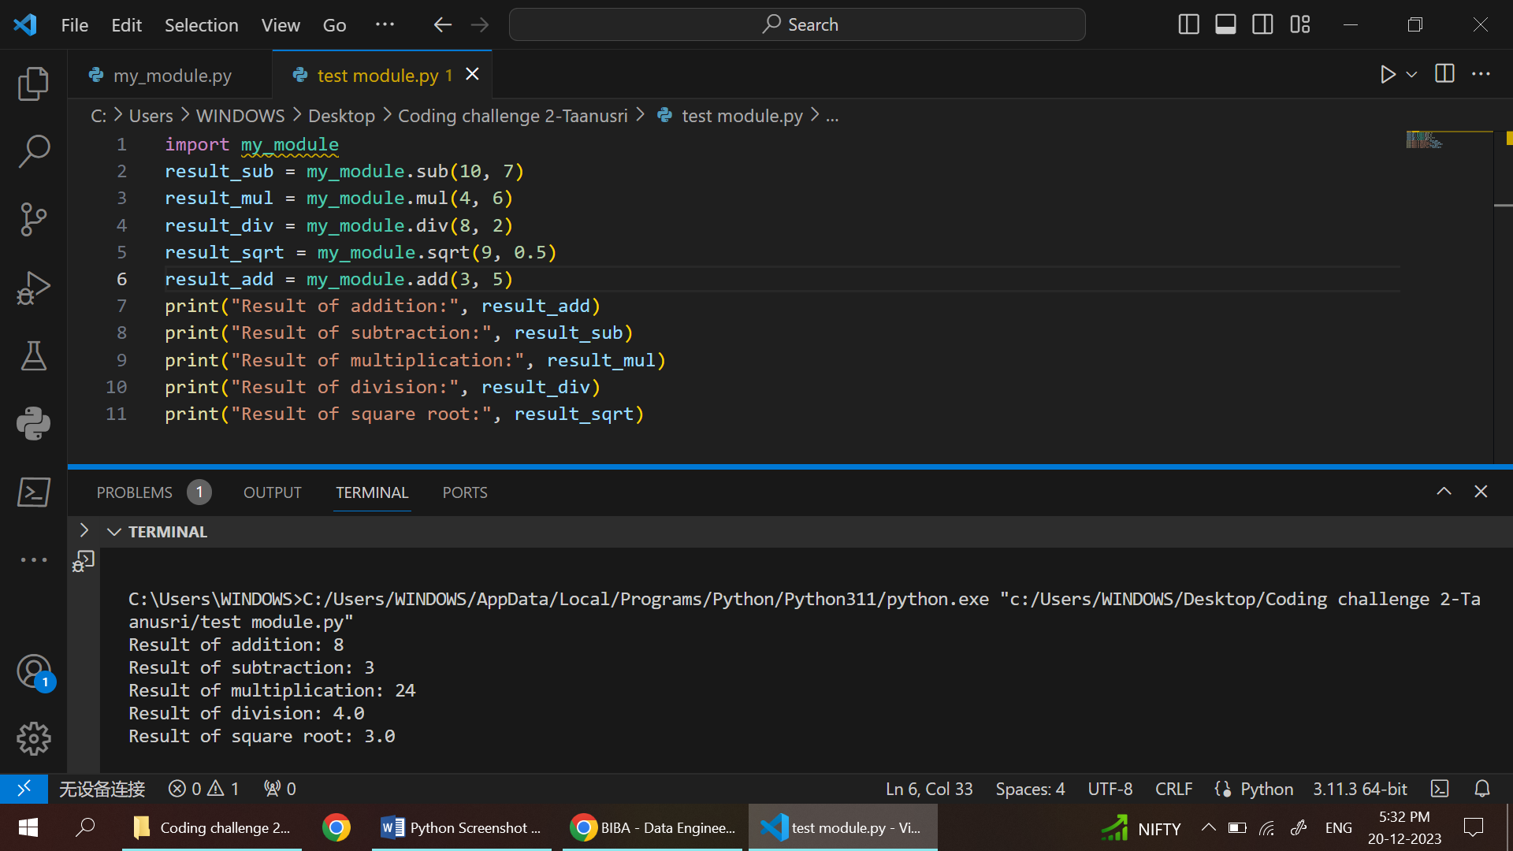

b. Renaming the Python module

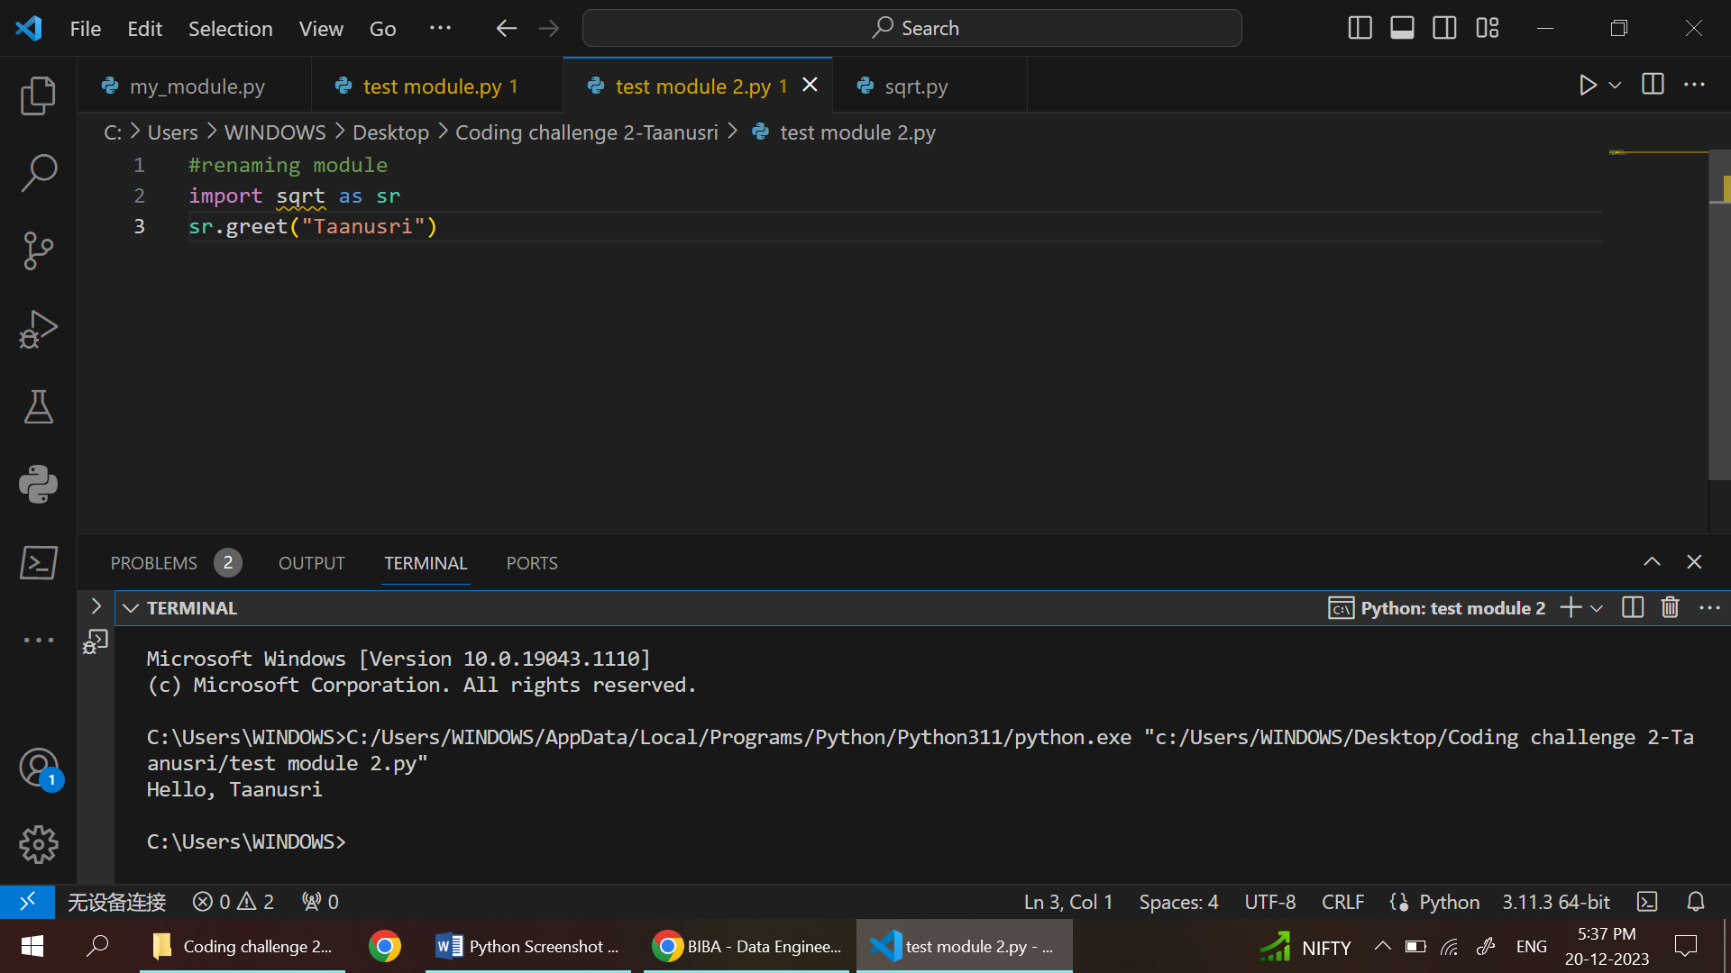a)The module is 1st created with name my_module and then it is saved in same path as the another module created(test module). The lines of code are written in my_module use def keyword and the values are returned in it with return keyword. The output values are printed in the test module

b)The module sqrt Is renamed as sr by just using the AS keyword then the value is returned and printed in test module 2.

2. Explain Pandas and numpy using Examples in PYTHON

a)PANDAS:

* Efficient for data manipulation and analysis.
* It consists two main structures:

DataFrame

Series.

* Pandas is an open-source data manipulation and analysis library for Python

import pandas as pd

s = pd.Series([1, 6, 8])

print(s)

#creating data frame

a = pd.DataFrame({'Name': ['Rita', 'lata', 'tom'],'Age': [25, 30, 22],'Salary': [50000, 60000, 45000]})

print(a)

#mean finding

total_salary=a['Salary'].mean()

#conitions

young_worker=a[a['Age']<25]

print (total_salary)

print(young_worker)

#sorting

sorted_salary = a['Salary'].sort_values()

print("Original DataFrame:\n", a)

print("\nSorted 'Salary' column:\n", sorted_salary)

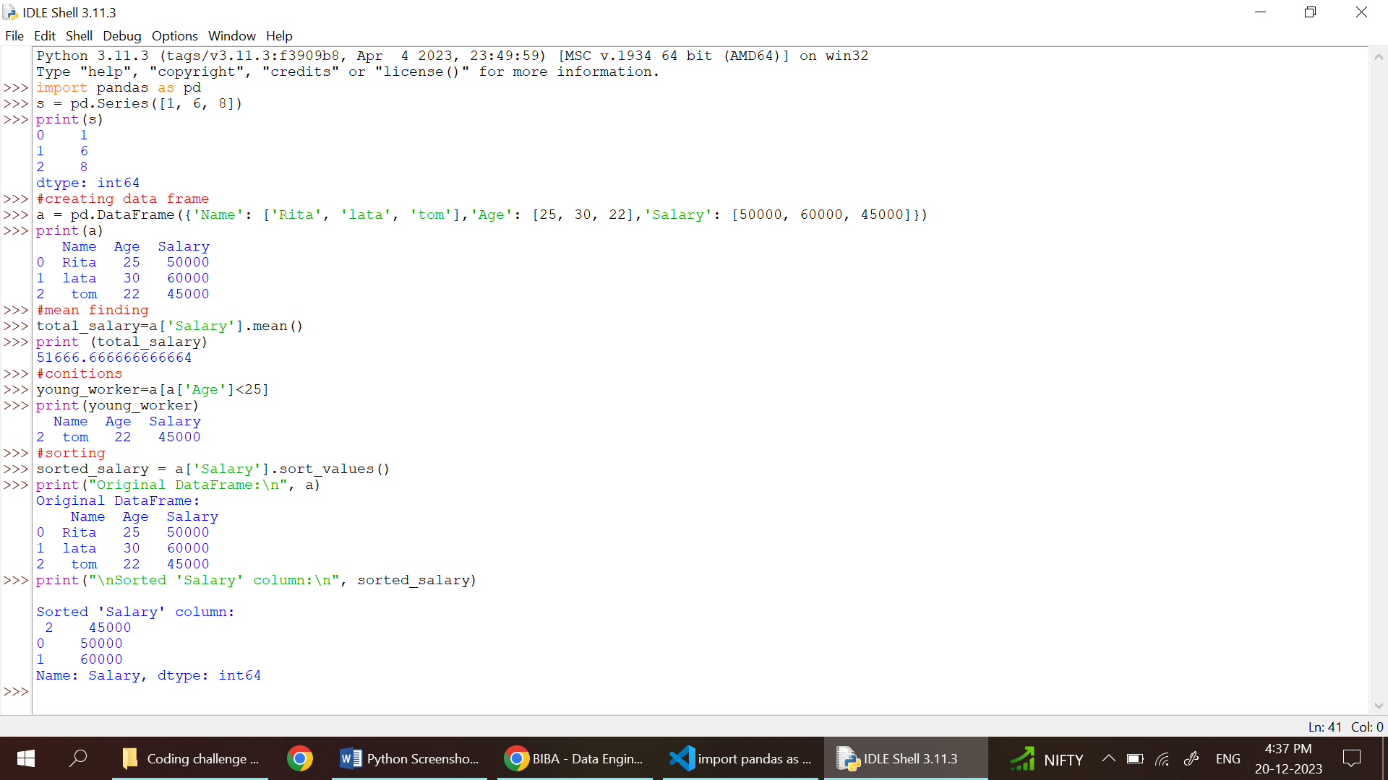

* In this a pandas are imported and a series is created and then it is printed. Then mean value, condition are given and the statement is printed.
* The sorting is done based ascending order of the salary in the given series.

b)numpy

* It is a numerical computing library in Python.
* 2 uses the `ndarray` for efficient array operations.

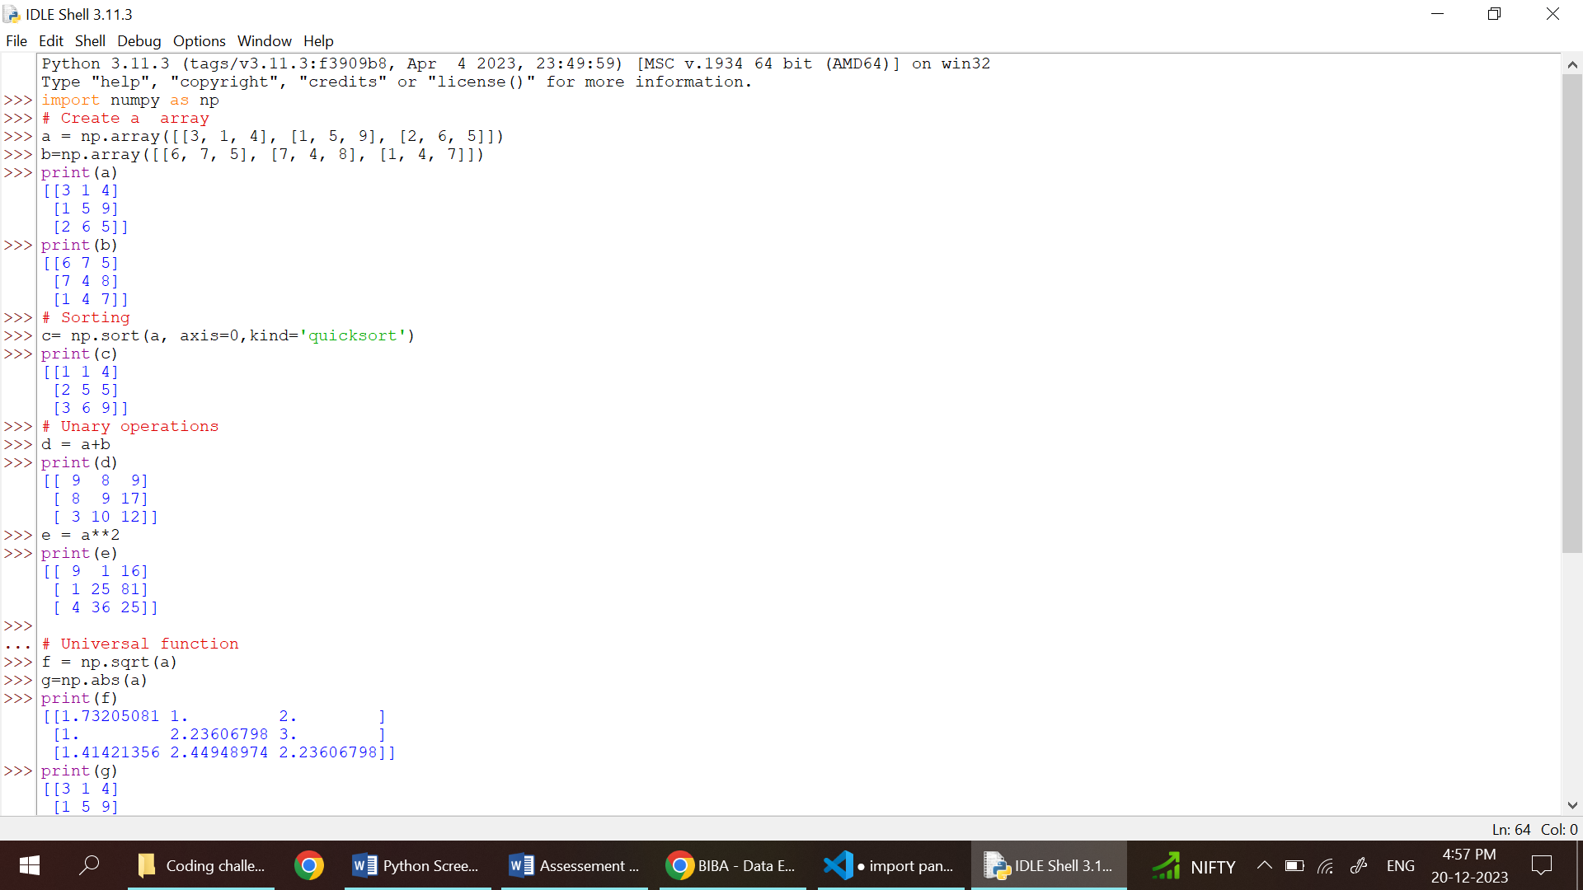

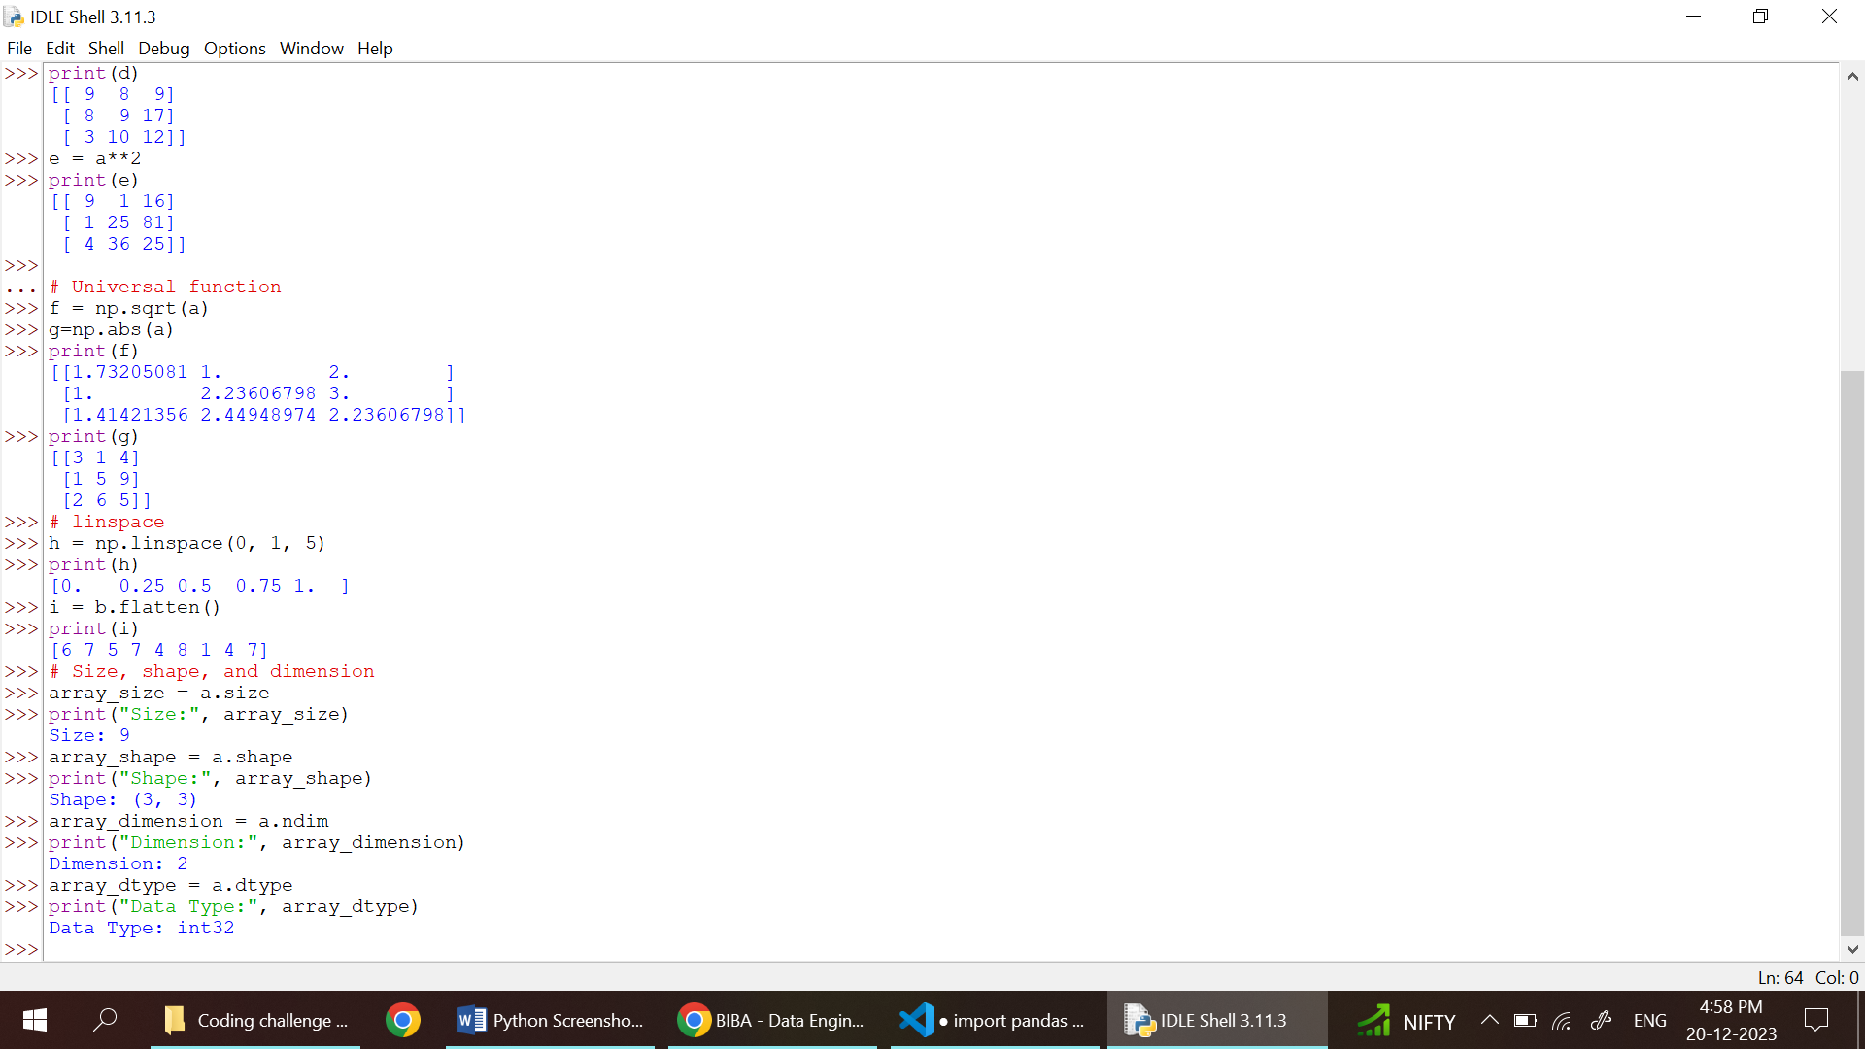

* The numpy are imported from the python library and a
* Array is created using the np .From the array addition, subtraction ,square root everything can be found by just giving( a+b). Then the array can be sorted with variety of sorts lie quick sort.
* The dimension of array ,shape of array, datatype of array everything can be found using this functions.